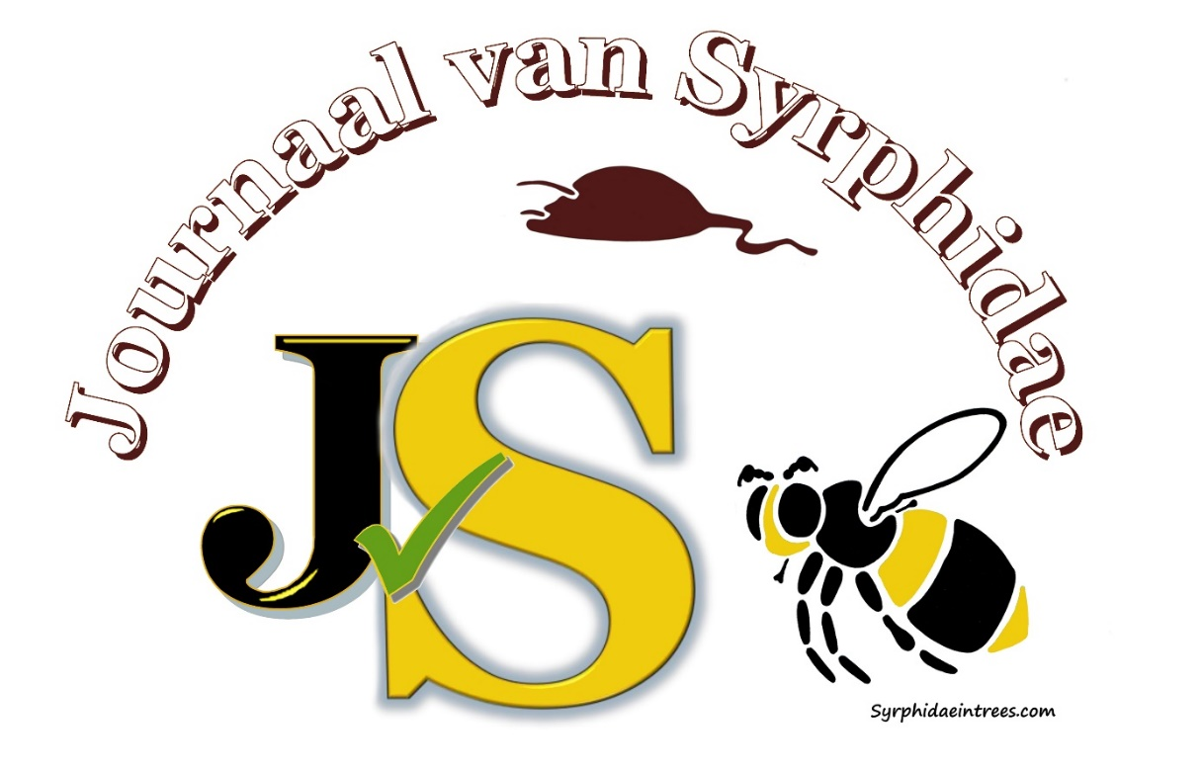

[title]

[authors]

[figure of paper]

ISSN 2949-6748 Volume [x] No. [x] [year]

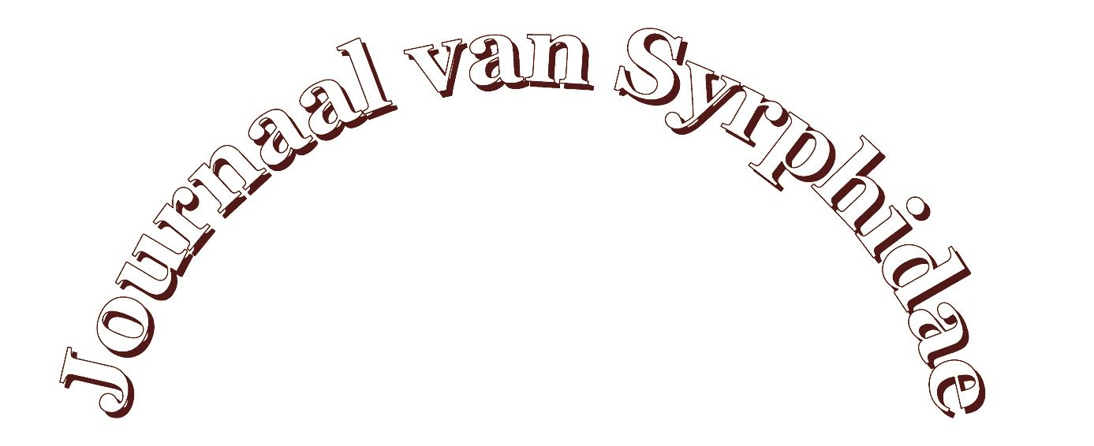

An international journal on Syrphidae, “Journaal van Syrphidae” (http://zoobank.org/References/632F826B-7A33-4CA7-80D6-9B96135409C1), founded in 2022 by the Syrphidae Foundation. JvS publishes original work in the form of articles, comments and symposium papers on all topics concerning Syrphidae (Insecta, Diptera) from all biogeographical regions.

Editor in Chief
Jeroen van Steenis. Syrphidae in trees, email: infojvs@syrphidaeintrees.com

Editorial Board
Leendert-Jan van der Ent, The Netherlands
Francis Gilbert, United Kingdom
Roger Morris, United Kingdom
Gerard Pennards, The Netherlands
Axel Ssymank, Germany
Tsung-Hsueh (Bill) Wu, Taiwan

Manuscripts
Manuscripts and other correspondences should be send to the Editor in Chief.
The aim of the journal and “instructions for authors” can be found on the webpage of JvS

Publishing
Publication is through free online open access.

Indexing
The papers are supplied with DOI and Zoobank registration numbers. The authors are requetsed to register in ORCID or preferably in zoobank to get unique electronical indentification numbers. See website for more information. JvS is indexed in Web of Science and Crossreff.

Funding
JvS is financed though the Syrphidae Foundation, and can only survive by donations of readers and other organisations or private persons gifts.

Organisations and private persons donating for the current Volume 1 are listed below.

- (https://www.veldshop.nl/en/)

- 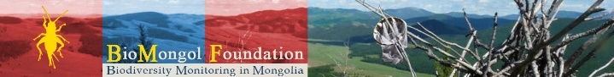
(https://www.biomongol.org/)

- Gerard Pennards
- Axel Ssymank
- Frieda Zuidhoff

[Donation button]

